Interface Design 18/19

Interface Design Assignment 1



Name: Ethan Southall

Student Number: s4911672

4th November 2018

# Game Design / Ideas

This game is set in Egypt and plays upon the idea of “The mummy’s curse” and thus uses a lot of desert themed assets. The gems have been deliberately chosen in colours which contrast with the yellow sand. In addition, gems have picked to try and convey value to the player. For example, the diamond is the rarest spawning item in the game and is also a valuable item in the real world. In addition, the gems will all be randomly spawned into the level, so that the player will not have the same experience every time and so a high score strategy can’t be developed. All the assets used are free from the unity asset store and all follow a similar desert themed, low poly look to them. Future work could include a “Grave Robber” as a hostile character who will attack the player and will thus deal damage to the player, forcing the game to end when the player’s health has been depleted. The reasoning behind make a collectible gathering game as opposed to a first-person shooter or a racer, is that the navmesh lends itself very well to point and click games, those other 2 genres mentioned above require more precise controls, which this navmesh does not provide.

# GUI Designs and Justification

## Low Fidelity UI

For the two main GUIs, Main Menu and HUD, I designed them according to either an Egypt theme, as the game is set in Egypt, and the other is a more generic zombie theme.

# HUD

Figure – Zombie themed HUD

Figure – Egypt Themed HUD

The first low-fidelity HUD (figure 1) is attempting to create an Egyptian theme. The scroll on the right side will have hieroglyphs on it, mimicking the Egyptian theme, and these will offer hints to the player about finding the places to visit on the map. A scroll infers reading and so has similarities to the real world according to usability heuristics (Nielson and Molich, 1990). This has been applied to other areas of this UI in the display of collectibles on the side and the foot icon for steps. I have applied similar methods to the generic zombie themed HUD (figure 2), this time keeping all the scores together for consistency, adding a brain icon instead of segmented circles for the health. Unfortunately, I struggled to think of a zombies themed way of displaying the places, so I settled for icons describing the places that will disappear once the place has been visited. For both designs, I kept the information and graphics to a minimum to avoid confusion (Nielson and Molich, 1990).

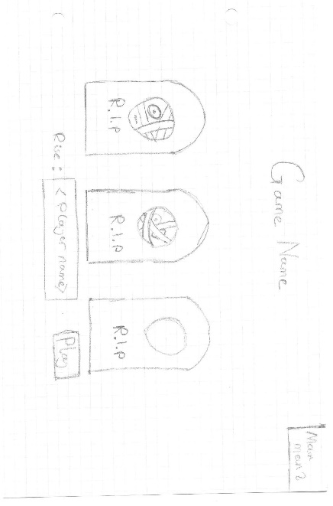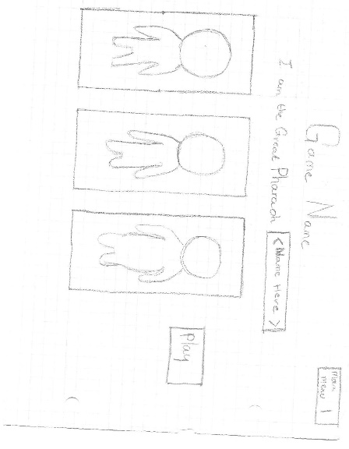

## Main Menu

Figure 4 – Generic zombie themed main menu

Figure 4 – Egypt themed main menu

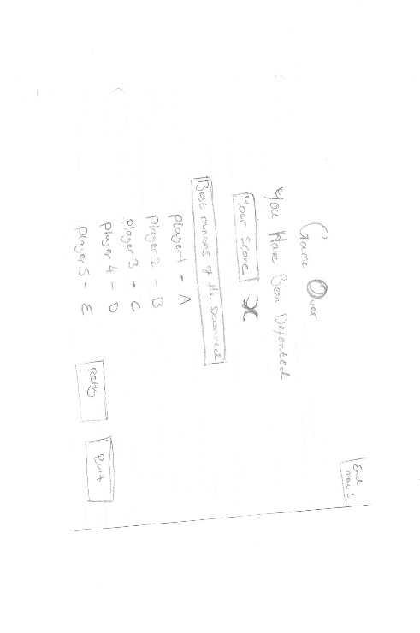The next GUI (figure 3) is an Egypt themed main menu. To add to player immersion and to add to the Game Flow (Hodent, 2017), the player is referred to as a pharaoh and will have a choice of 3 characters to pick from in the form of character portraits, to further mesh with the Egyptian theme. The play button has been situated next to the character portraits so that the player doesn’t have to move far to start the game. I stuck to a similar methodology for the other version, putting player portraits on tombstones and attempted to add a flow to the main menu so that the player would not leave out any important information.

# Game Over

Figure 6 – Game Over GUI 2

Figure 5 – Game Over GUI 1

Both “Game Over” GUIs are fairly similar. Both present the player’s score at the top and the other high scores in descending order underneath. By displaying the high scores, the player will hopefully be enticed to carry on and try to beat the high score. Both adapt the Egypt/Zombie themes to keep to game and GUI consistency. For figure 5, the retry and quit have been placed next to the players score, so that they player can go straight back into the game to try again or leave, whereas figure 6 has them at the bottom of the screen, so the player will most likely read through the high scores before continuing.

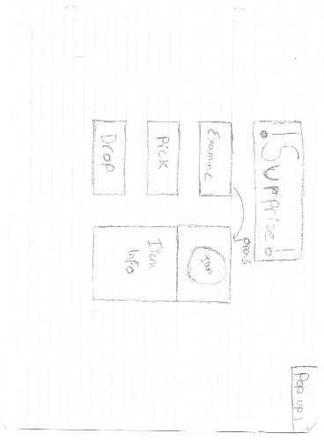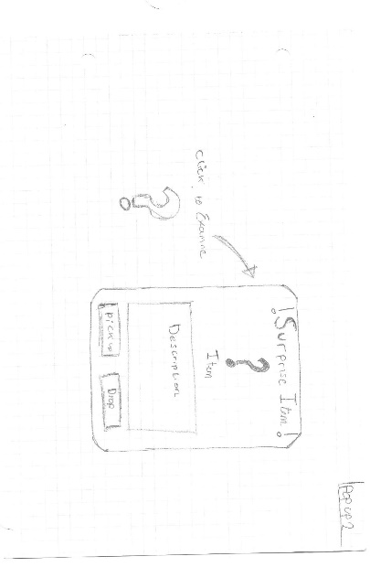

## Popup Menu

­

Figure 8 – Popup GUI 2

Figure 7 – Popup GUI 1

The Popup GUIs here are also quite similar, with the main distinction being how the player will experience it. In GUI 1, the player will see the “examine” in game, therefore giving the player the choice to go interact with it, upon which they will receive a tablet like interface with the item description with a pick up and drop option at the bottom of the GUI. In contrast, GUI 2 would activate upon walking over and will give the player the information about it once they click the examine button. One issue with this GUI is that it could be a bit too surprising to the player and could therefore ruin the player’s immersion.

# High Fidelity UI

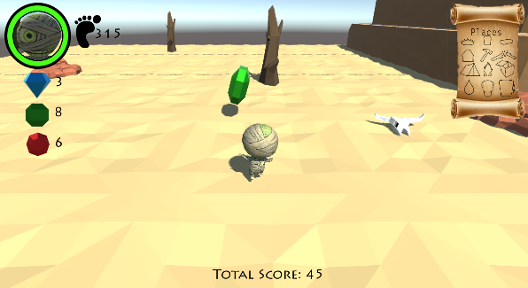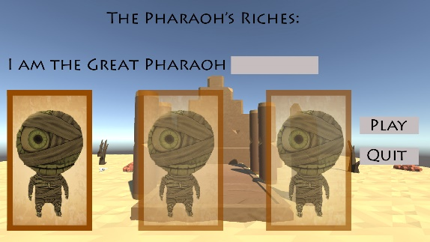

Figure 9 – HiFi Main Menu

Figure 10 – HiFi HUD

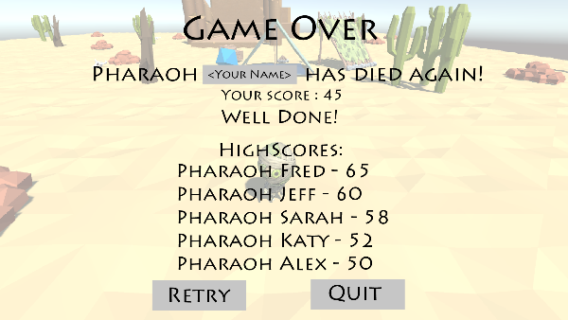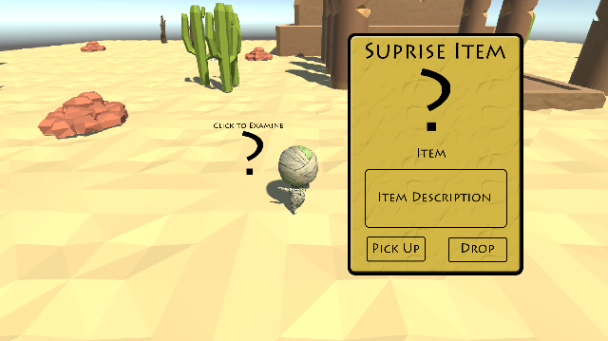

Figure 12 – Surprise

Figure 11 – HiFi Game Over

For the high-fidelity UI, I decided to go with the Egypt theme for the GUI, as it fits the game better than a generic zombie interface. A few changes were made from the low fidelity prototypes to the high-fidelity prototypes., such as including a “Well Done” message to counteract not making the high score list and to encourage them to try again, as per Hodent’s “Emotion” section in his Engage-Ability framework (Hodent, 2017). This framework is the reasoning behind display how many gems the player has collected in the HUD GUI. By displaying how many gems the player has collected, even if they don’t make the high score, they can still feel proud of what they accomplish.

# References

Hodent, C., 2017. The Gamer's Brain: How Neuroscience and UX Can Impact Video Game Design. CRC Press

Nielsen, J and Molich,R., 1990. Heurostic evaluation of user interfaces [online]. Available at: <https://dl.acm.org/citation.cfm?id=97281>

# Appendices

Ricochet, Chibi Mummy, <https://assetstore.unity.com/packages/3d/characters/chibi-mummy-60462>

Broken Vector, Low Poly Survival Essentials, <https://assetstore.unity.com/packages/3d/props/tools/low-poly-survival-essentials-109444>

Nekcom Entertainment, Ancient Ruins in the desert – Part 1, <https://assetstore.unity.com/packages/3d/environments/ancient-ruins-in-the-desert-part1-19175>

23 Space Robots and Counting…, Free Low Poly Desert Pack, https://assetstore.unity.com/packages/3d/environments/free-low-poly-desert-pack-106709

Anonymous, Bucket icon – iron bucket png image download [online], Kisspng. Available from: <https://www.kisspng.com/png-iron-bucket-png-image-download-42969/>

Clip2Art, Paper clipart old paper #98 [online], Clip2Art. Available from: <https://clip2art.com/explore/Paper%20clipart%20old%20paper/#go_post_6546_paper-clipart-old-paper-5.png>

Techflourish, Gold queen crown image free [online], TechFlourish, Available from: <https://techflourish.com/categories/gold-queen-crown-clipart.html>

Hasshe, Blue baby footprints clipart blue baby footprints clip art at [online]. Hasshe.com, Available from: <http://hasshe.com/blue-baby-footprints-clipart-5b7b34d92756dd6f6c836d19/>

Cliparts Zone, Cliparts broken things [online], Available from: <http://hasshe.com/blue-baby-footprints-clipart-5b7b34d92756dd6f6c836d19/>

Kathleenhalme, Transparent bricks translucent [online], available from: <https://kathleenhalme.com/explore/transparent-bricks-translucent/>

Freecliparty, Free campfire clipart images [online], available from: <http://freecliparty.com/free-stock-images/4264/free-campfire-clipart-images>

Pngimg.com, Png images: gravestone [online], available from: <http://pngimg.com/imgs/fantasy/gravestone/>

Melbournechapter, hut picture carnival [online], available from: <https://melbournechapter.net/explore/hut-clipart-carnival/>

Clipartmax, drop water clip art – clip art water drop [online], available from: <https://www.clipartmax.com/middle/m2K9A0m2d3N4Z5m2_drop-water-clip-art-clip-art-water-drops/>

Haydanthoigian.net, Tent clipart 15 0 [online], available from: <http://www.haydanhthoigian.net/tent-clipart/tent-clipart-15-0/>

Free clip arts, Box clipart wooden box #2593657, available from : http://mariafresa.net/single/2593657.html